Lab 1E - What's the Relationship?

Directions: Follow along with the slides and answer the questions in **bold** font in your journal.

## Finding patterns in data.

* To discover (*really*) interesting observations or relationships in data, we need to find them!
  + Which is difficult if we only look at the raw data.
* The best tool for finding patterns is often ... your own eyes.
  + Plots are an excellent way to help your eye search for patterns.
* In this lab, we'll learn how to include more variables in our plots to make them more informative.
* Import the data from your class' *Food Habits* campaign and name it food.

## Where's the variables?

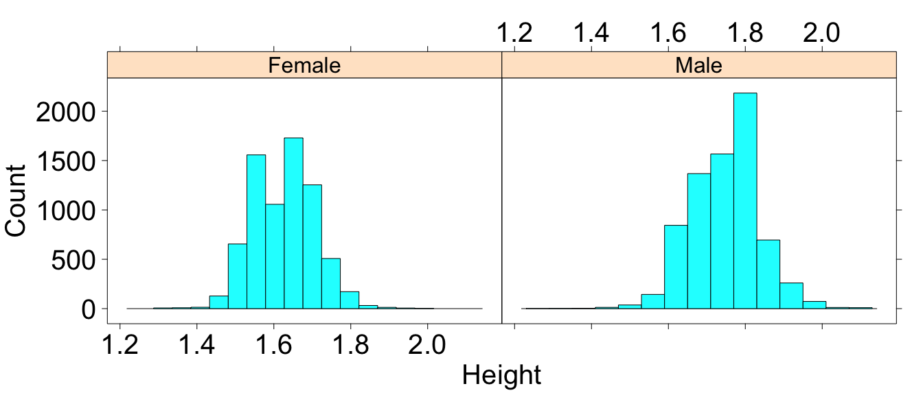

* **How many variables were used to create this plot? Which variables were used and how were they used?**

## Multiple variable plots

* The previous graph is an example of a *multiple variable plot*, which means that more than a single variable was used. In this case:
* Variable 1: *height*
* Variable 2: *gender*
* Multiple variable plots are tools for finding *relationships* between data.
* Let's take our food data and make some new multiple variable plots you haven't created before!

## scatterplots

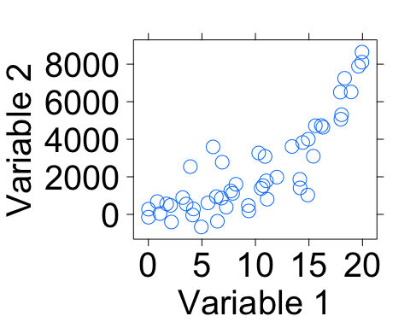

## Creating scatterplots

* Scatterplots are useful for viewing how one *numerical* variable relates to another *numerical* variable.
* Fill in the blanks to create a scatterplot with sodium on the y-axis and sugar on the x-axis.

xyplot(____ ~ ____, data = food)

## Scatterplots in action

* Use a scatterplot to answer the following questions:
  + **Do snacks that have more calories also have more total_fat? Why do you think that?**
  + **What happens if you swap the calories and total_fat variables in your code? Does the relationship between the variables change?**
  + **Does the relationship between calories and total_fat change when the snack is either Salty or Sweet? Write down the code you used to answer this question.**

## 4-variable scatterplots

* When we make scatterplots, we can include:
  + 1 numerical variable on the x-axis
  + 1 numerical variable on the y-axis
  + Use 1 categorical variable to facet our scatterplot
  + Change the color of the points based on another categorical variable
* To change the color of our points, we can include the groups argument much like we did for bargraphs (use the *search* feature in the *History* pane if you need help).
* **Create a scatterplot that uses these 4 variables: sodium, sugar, healthy_level, salty_sweet.**

## Multiple facets

* It can sometimes be helpful to facet on more than 1 variable.
  + Splitting the the data using 2 facets can give us additional insights that might otherwise be hidden.
* Create a dotPlot or histogram of the calories variable, but facet the data using:

healthy_level + salty_sweet

* **How does the healthy_level of a Salty or Sweet snack impact the number of calories in the snack?.**

## On your own

* Answer the following questions by creating an appropriate graph or graphs.
  + **Do healthier snacks cost more or less than less healthy snacks?**
  + **What other variables seem to be related to the cost of a snack? Describe their relationships.**